Used JWT in API Gateway to check the availability of a flight
- Added the Bearer token generated at jwt.io
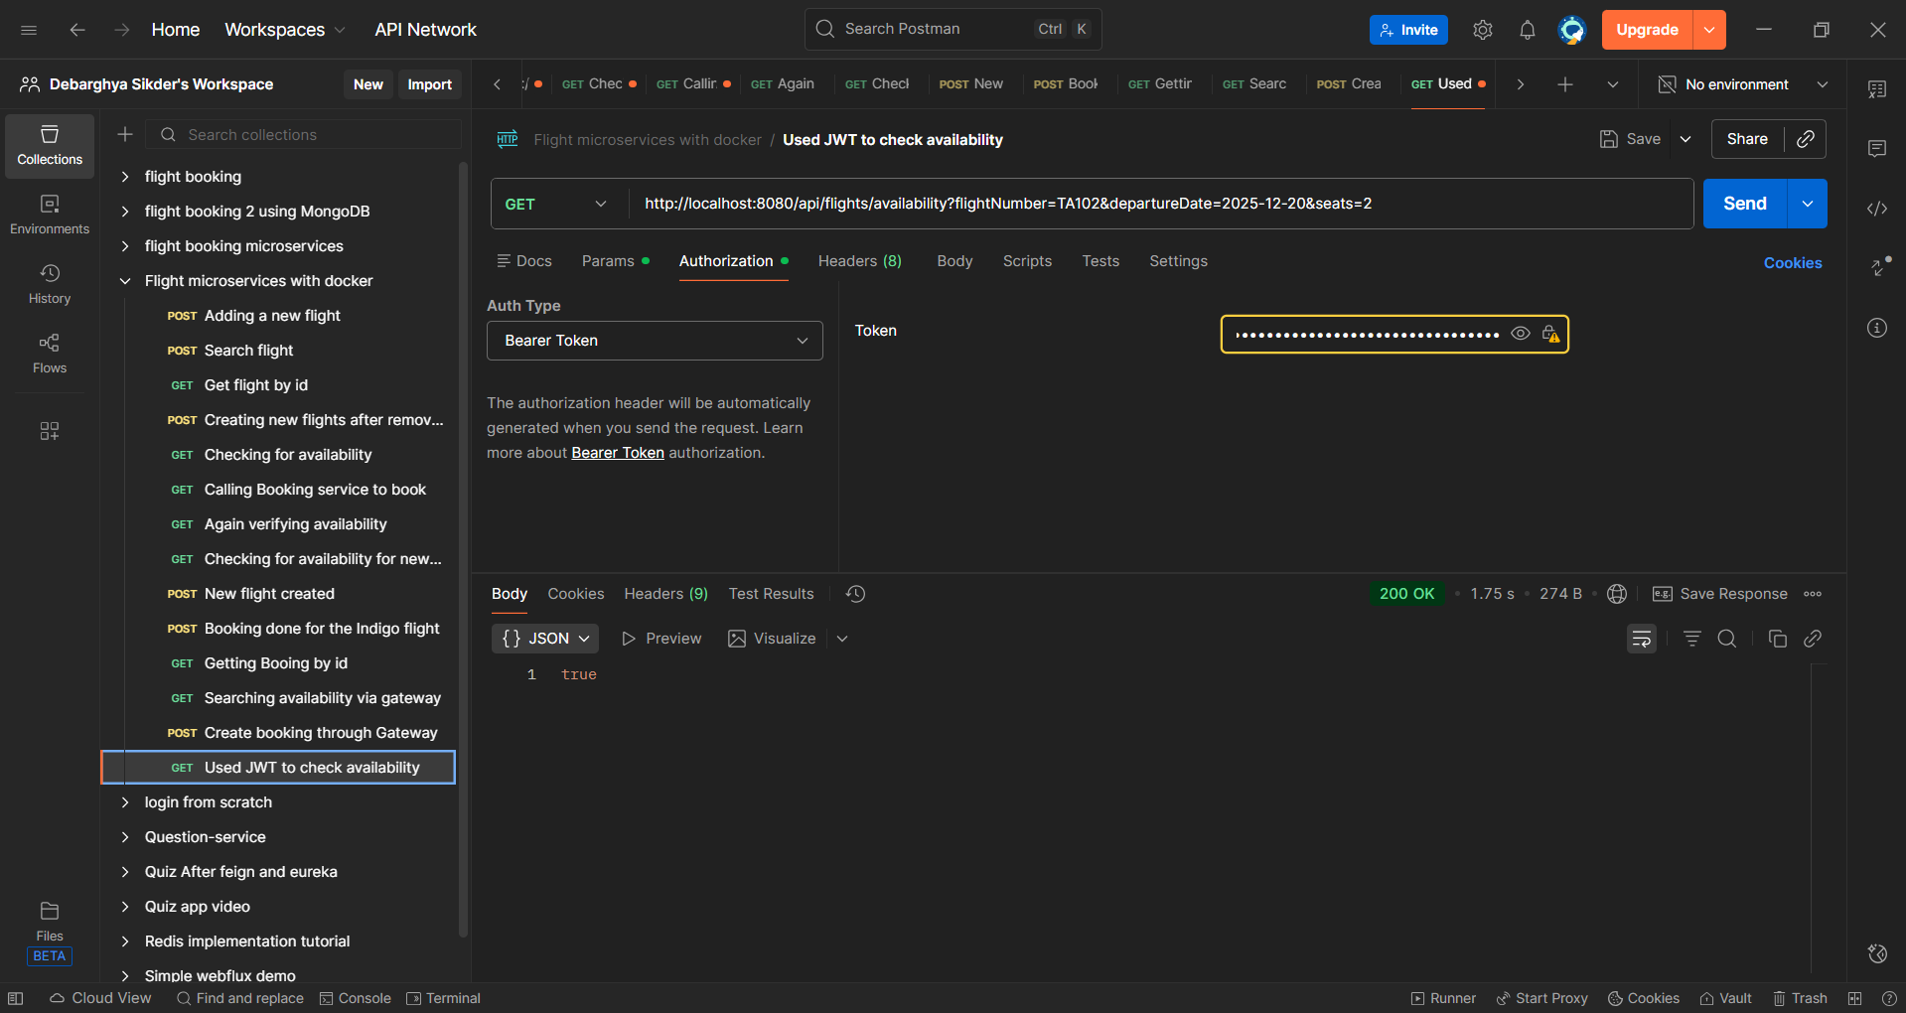

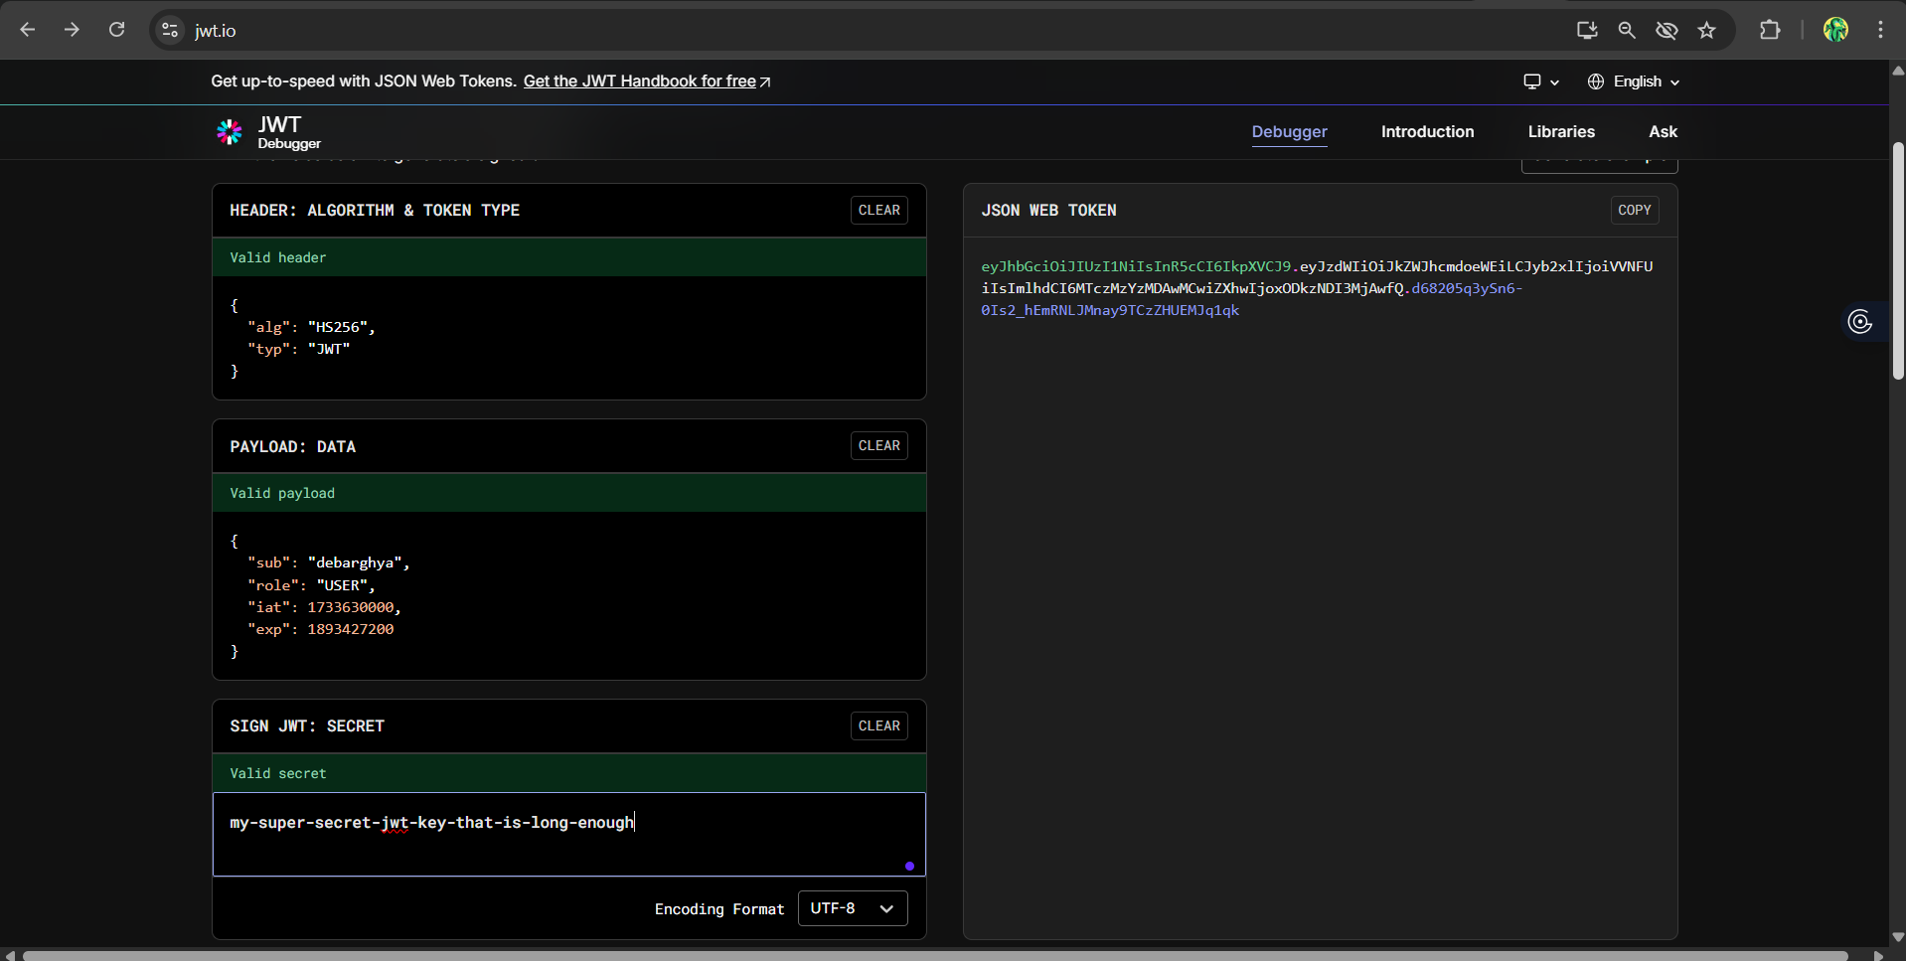

Checking flight availability after implementing Docker
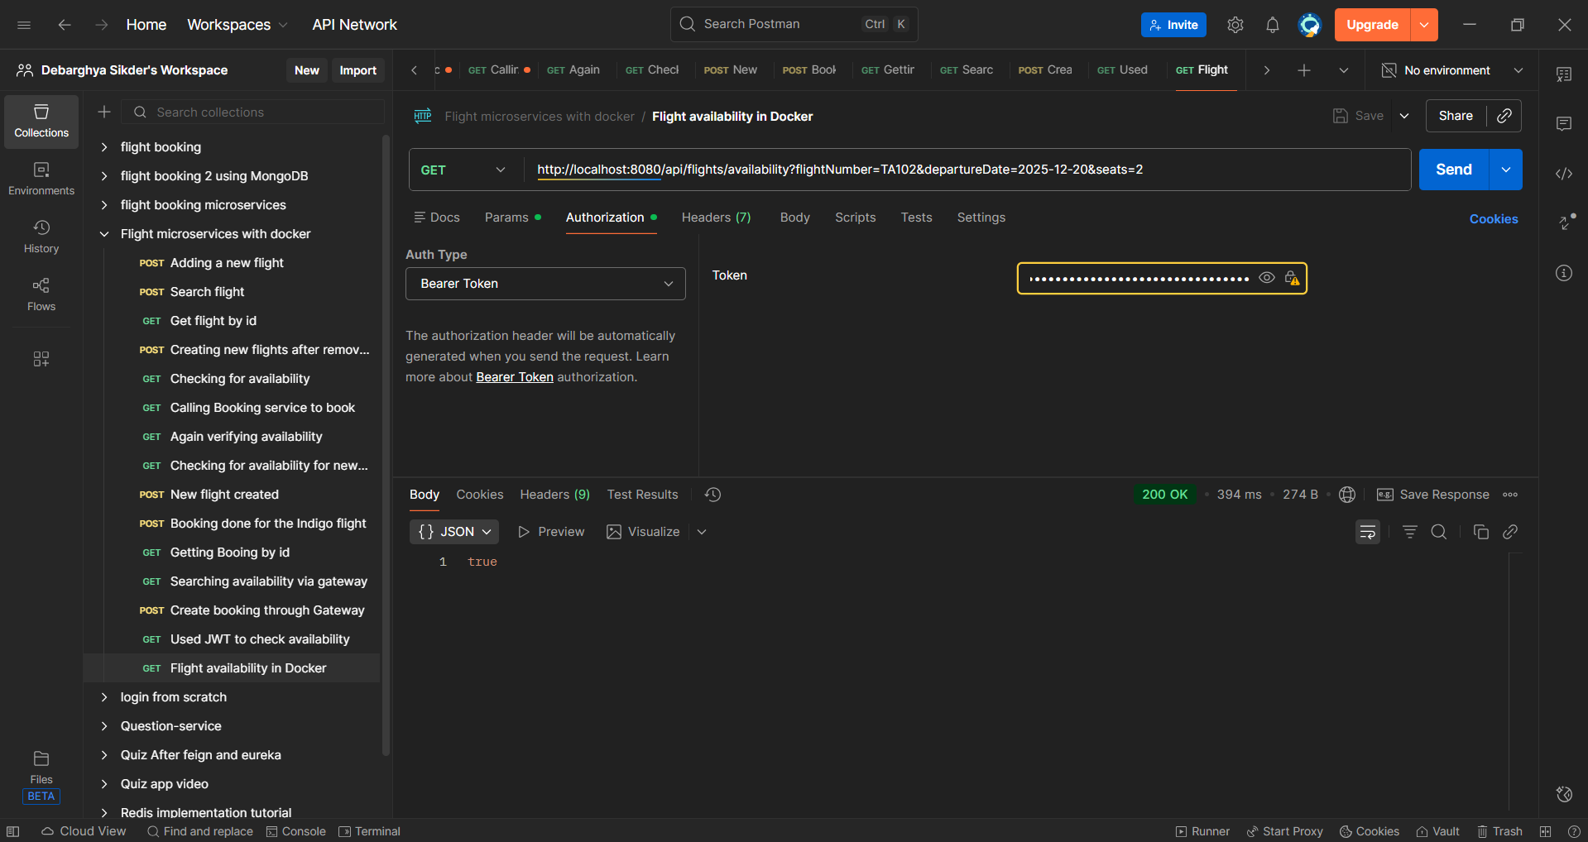

Booking the flight (through API Gateway)
